**Module Title**

**Internet Technology**

**Assessment Weightage & Type**

**Individual Coursework**

**Year**

**2024**

**Student Name: Dipak Kumar Yadav**

**Sec: B**

**UWE ID: 23085204**

**Task 1 - Getting started with moqups.com account setup and tools overview**

1. Create a free account in moqups.com. Follow with the click on the a Create a Free Account. You can get this screen. Let’s go with Sign up with Google

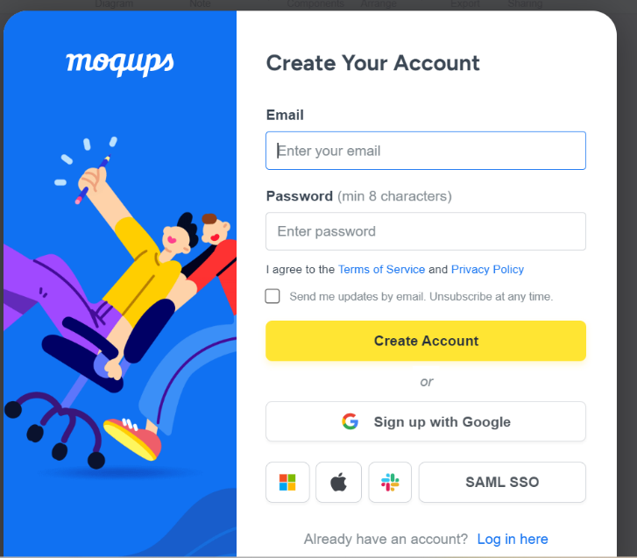

1. You will see this screen. Select Blank Project & Rename as “Wireframe & Mockup”

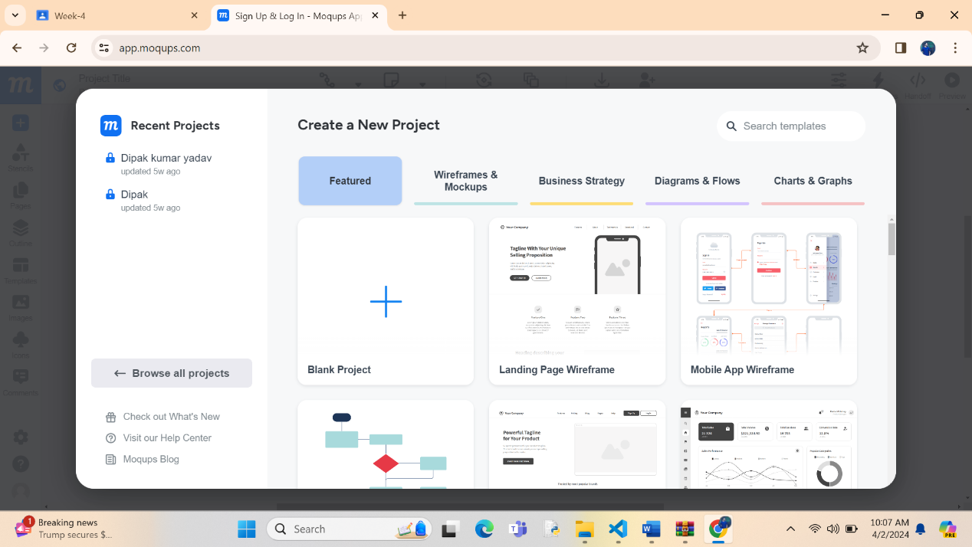

3.You will see this screen

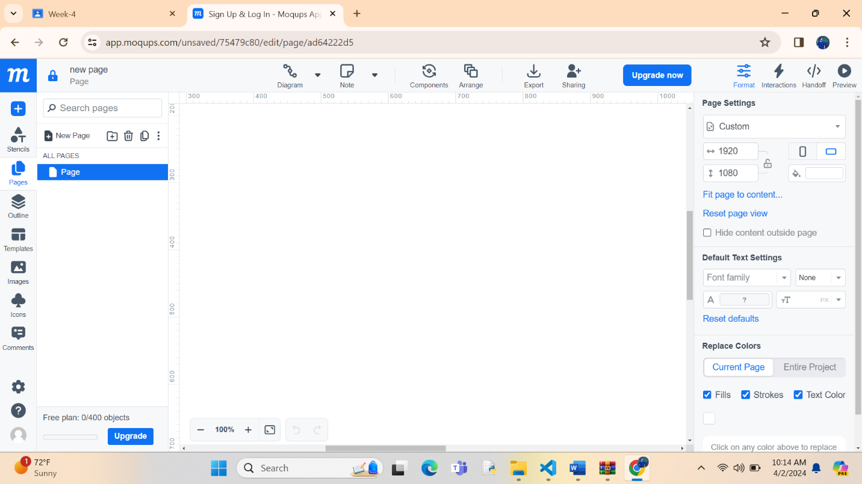

4.Check for components/icons at left side:

* 1. Stencils
  2. Pages
  3. Images

**5.Pages Icon:** How to work on Page Setting?

A Select Pages

B Select Page

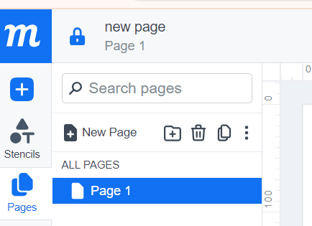 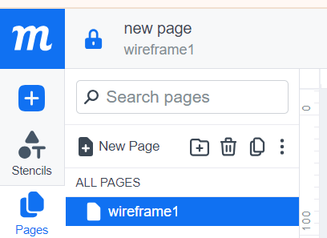

C Right Click > Page Settings. Set Width of 800 and Height of 700

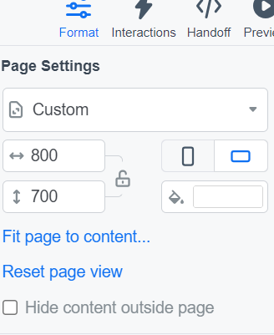

6 Check what is there for you in **Stencils Icon**

* + 1. Rectangle
    2. Link
    3. Heading
    4. Paragraph
    5. Image Placeholder
    6. Bar chart
    7. Line chart.
    8. Database
    9. Direct data
    10. Disk
    11. Data
    12. Loop limit

7. Drag and drop some of the objects in Stencils that you can use to create wireframe. Do not limit with what is just mentioned below.

* + 1. Rectangle
    2. Link
    3. Heading
    4. Paragraph
    5. Image Placeholder
    6. Banner
    7. Search
    8. Menus & Navigation
    9. Form Controls
    10. Table
    11. Calendar
    12. Map and
    13. Phone
    14. Video player
    15. Audio player
    16. Checkbox

Others you can use

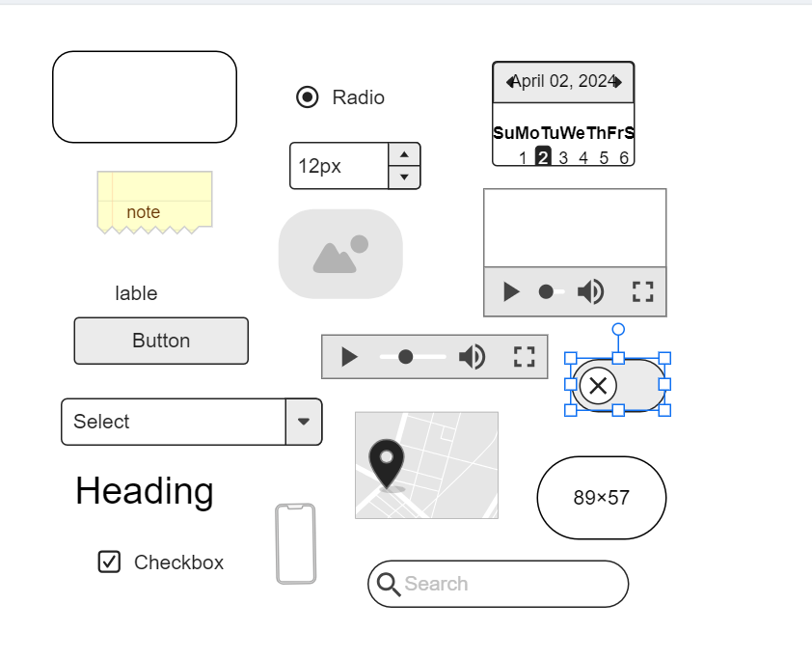

**Task 2 – Design the below like wireframe structure. Use your own creativity.**

